Module: | Student Records
Business Process Name: | Scheduler Role – Maintaining an In-Person Tier One Section
Created By: | Sergio Cañez
Creation Date: | May 18th, 2018

Business Process Summary

Business Process Procedures:

Step A | Action— During Open Scheduling
Navigate to Schedule New Course in UAccess Student:
Navigator>Curriculum Management>Schedule of Classes>Maintain Schedule of Classes (For combined sections, it will be Schedule Class Meetings* instead)

Or

It can be found on the UA Schedule of Classes landing page
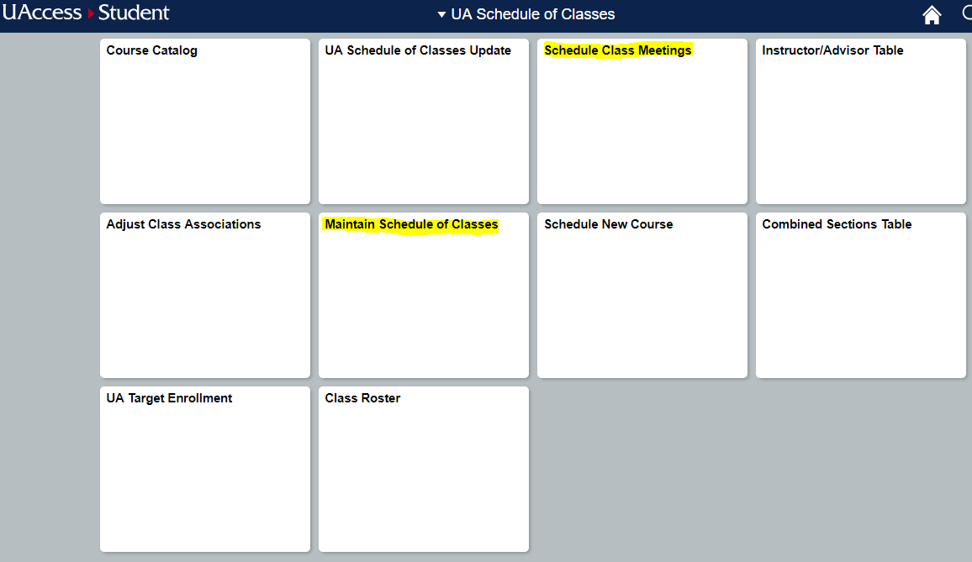
*For Combined Sections, Schedule Class Meetings is used to update the Meetings Tab. For information to be updated on the Basic Data or Enrollment Cntrl tab, you will still use Maintain Schedule of Classes.
Information that can be updated on the Basic Data page:
- Session
- Class Section
- Start/End Date (For approved DYN session sections)
- Campus/Location
- Instruction Mode
- Class Attributes
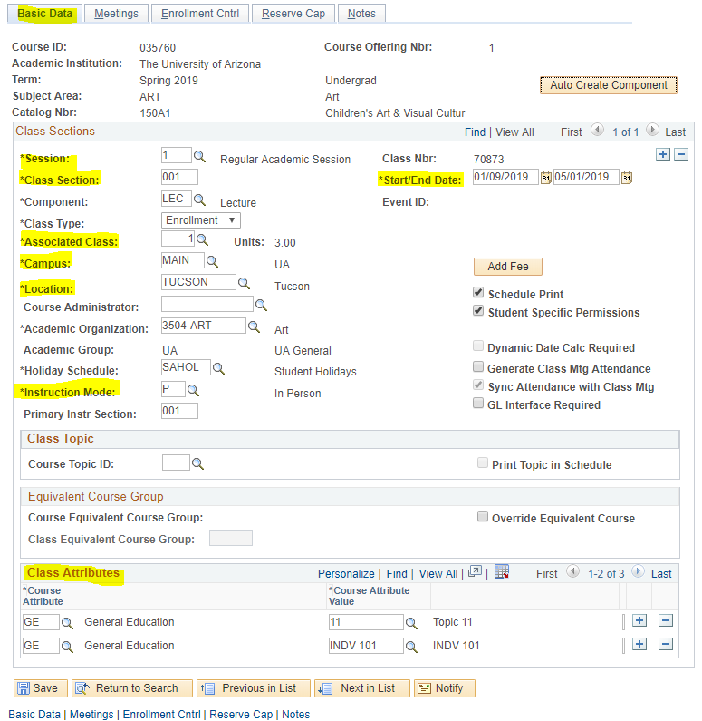
Information that can be updated on the Meetings page:
- Facility ID (for use in Online and Dept Controlled Rooms)
- Time and Days Met
- Instructor information (including Grade Access and Workload)
- Room Characteristics
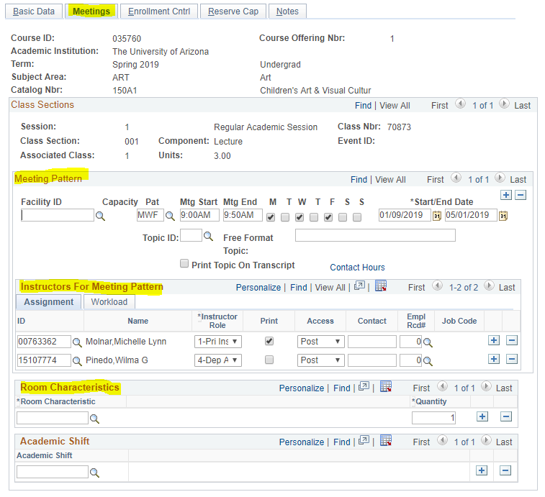
Information that can be updated on the Enrollment Cntrl page:
- Add or Drop Consent
- Requested Room Capacity (Optimizer will no look for rooms smaller than this number)
- Enrollment Capacity
- Waitlist Capacity

Step B | Action— After Open Scheduling
 | After Open Scheduling has closed, you will need to submit RCS Online Section Forms to updated the Schedule of Classes: http://www.registrar.arizona.edu/courses/rcs-online-section-forms
 | Click on the red “RCS Online Section Forms” link.
Sign in with WebAuth.
(If you don’t have access to these forms, please have your department’s Business Manager of Department Head email rcshelp@email.arizona.edu with your Employee ID and subject you should have access to submit forms for)
 | Select Change to modify an already existing section.
Things to select before modifying:
- Select the Term
- Select the Session
- Select the Subject Area
- Select the Section Number
- Click the “Get PeopleSoft Section Information” button

The Meeting Pattern information will be un-editable until the above steps are completed.
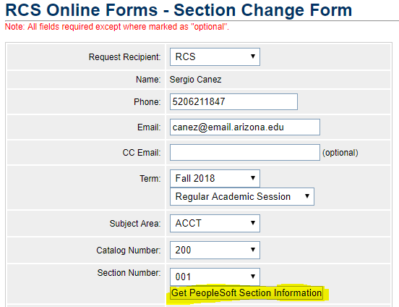
Edit the information as needed:
- Meeting Pattern information
  - Days met
  - Start/End Time
  - Facility
  - Instructor
- Enrollment/Waitlist Capacity
- Add/Drop Consent
- Course notes
- Additional Comments for clarification or other requests
 | Click Submit.

Appendix

