Module: | Student Records
Business Process Name: | Scheduler Role – Adding an In-Person Tier One Section
Created By: | Sergio Cañez
Creation Date: | May 18th, 2018

Business Process Summary

Business Process Procedures:

Step A | Action— Useful information from the Course Catalog
Navigate to the Course Catalog in UAccess Student:
Navigator>Curriculum Management>Course Catalog>Course Catalog

Or

It can be found on the UA Schedule of Classes landing page
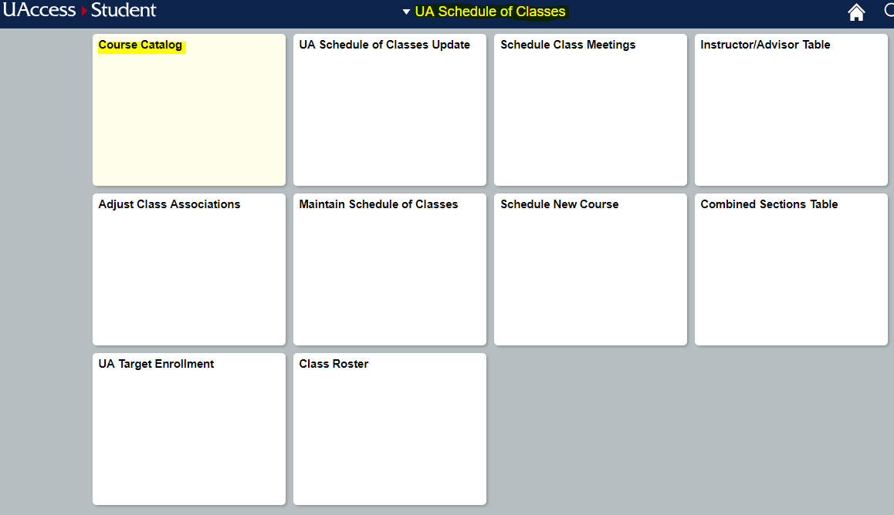

Identifying a Tier One Section:
- Will have Catalog Number of 150A#, 150B#, 150C#, 160A#, 160B#, 160C#, 160D#, 170A#, 170B#, or 170C#
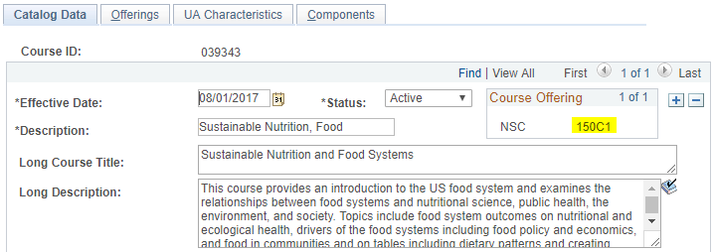
- Will have Course Attribute of General Education (GE) with one of the following values: T1-INDV, T1-NATS, or T1-TRAD
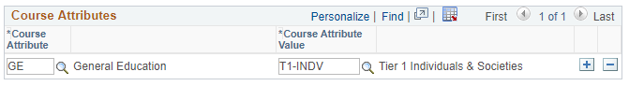
Some of the items to look for:
- Make sure the course is active
- Units
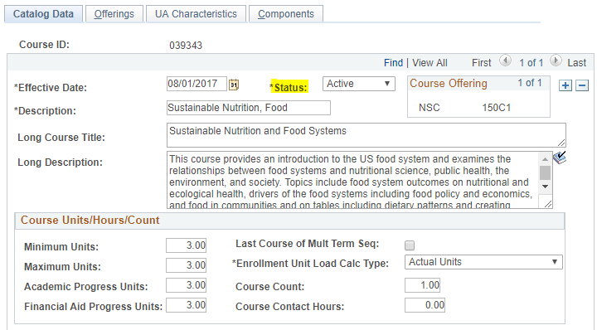
- Components
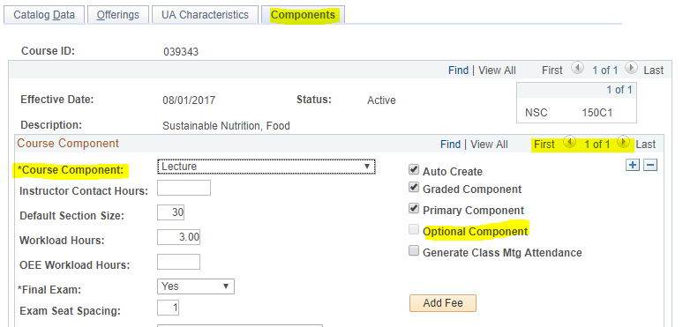

Step B | Action— Adding the Section
Navigate to Schedule New Course in UAccess Student:
Navigator>Curriculum Management>Schedule of Classes>Schedule New Course

Or

It can be found on the UA Schedule of Classes landing page
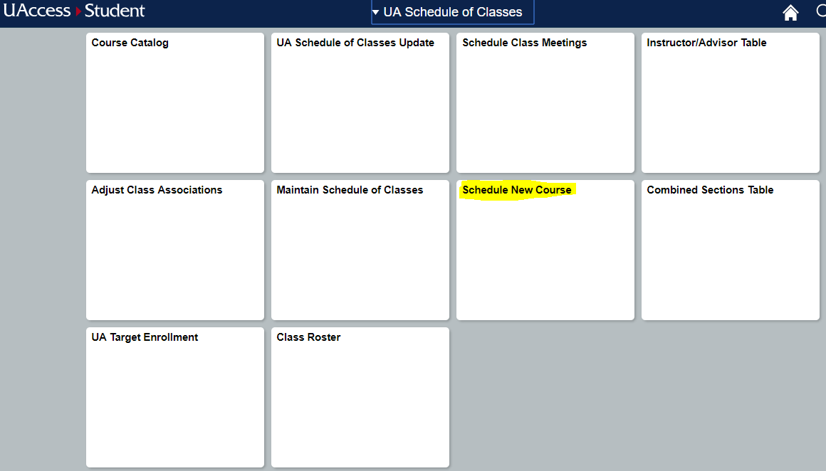
Search by Term (Required), Subject Area, and Catalog Number
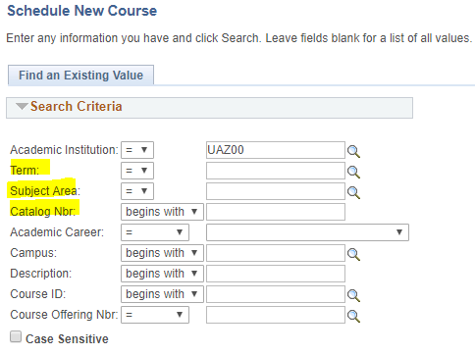
On Basic Data tab, the following is needed to be entered:
- Class Section Number
  - For Main: 001-099 In-Person, 101-199 for iCourse
  - For Distance: 001-099 all instruction modes
  - For UA Online: 201-299 all instruction modes
- Associated Class Number: Must match section number minus leading zeroes and letters (i.e. section 002A would be 2)
- Campus and Location
- Instruction Mode
- Session
- Component (Lecture, Discussion, Laboratory, etc)
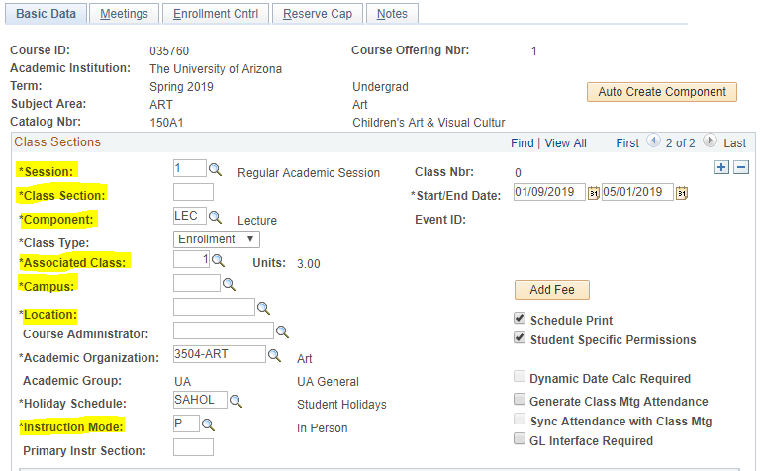
On the Meeetings Tab, the following information can be entered:
- Facility ID
- Meeting Pattern: Start/End Time, Days Met
- Instructor information: Role, Grade Access, Workload
- Room Characteristics (May have to save before this field appears)
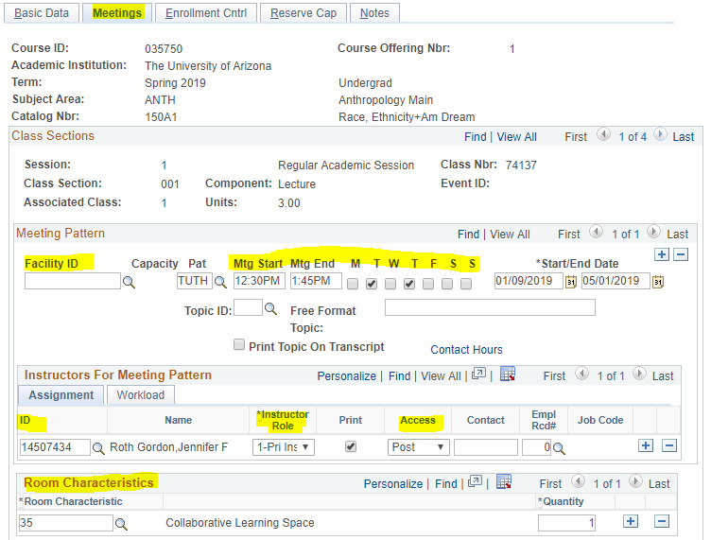
On the Enrollment Cntrl tab:
- Add/Drop Consent
- Requested Room Capacity
- Enrollment Capacity
- Waitlist Capacity
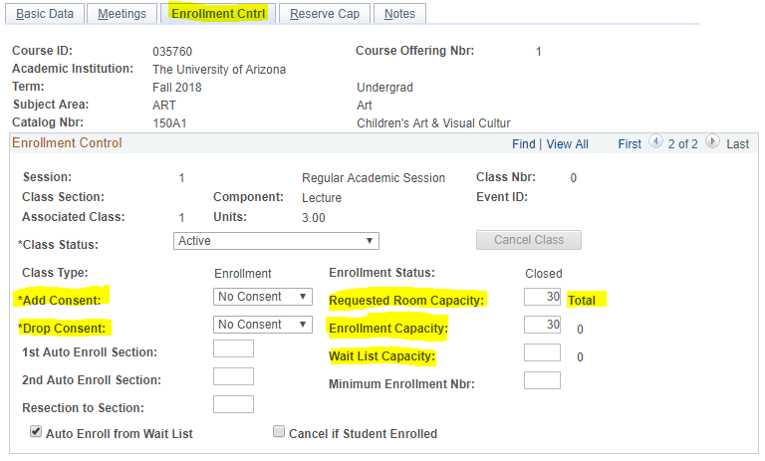
 | Save.

Appendix

