Module: | Student Records
Business Process Name: | How to manage Reserve Cap tab
Created By: | Sergio Cañez
Creation Date: | 5/31/2018

Business Process Summary

This guide reviews how to manage the Reserve Cap Tab in Schedule of Classes. This BPG does not review how to add a whole course. For more help, go to the Office of the Registrar, Schedule of Classes Resources.

Business Process Procedures:

Step A | Action— How to manage Reserve Cap Tab
Navigate to the course in Course Catalog. UAccess Student> Administrative Staff>Navigator>Course Catalog>Course Catalog.

Go through Course Catalog Checklist
- Check that is Active
- Check Catalog Data
  - Min & Max Units
  - Repeat for Credit
  - Allow Multiple in Term
  - Cross listings
- Check Components
- Components (Required & Optional)
 | Navigate to the Schedule of Classes. UAccess Student> Administrative Staff>Navigator>Schedule of Classes>Schedule New Course, or if sections already exist use Maintain Section of Classes (or UA Schedule of Classes Update after Open Scheduling).
Information on the Reserve Cap tab:

- Reserve Capacity: The Rerserve Capacity field is used to reserve a select amount of seats, using a Requirement Group, for a section without reserving the entirety of the section for that group. This can be beneficial in reserving seats for students in a particular major and allowing the rest of the available seats to be taken by other students.
- Reserve Capacity Sequence: Reserve Capacity is setup in a sequence for the reservation of seats. You will enter in a Start Date, Requirement Group, and Cap Enrl (number of seats you are reserving for that Requirement Group).
- Enrollment Total: Number of students who have enrolled who meet the Requirment Group
- Start Date: The date that the reservation will begin. Before this date, the seats are not reserved for the Requirement Group.
- Requirement Group: This field is to enter the Requirement Group that will restrict seats to students who meet the requirements.
- Cap Enrl: Number of seats to be reserved for that sequence. (Cannot be greater than the Enrollment Capacity listed on the Enrollment Cntrl tab.)
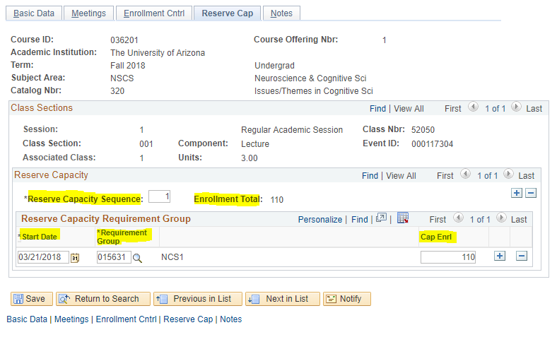
How to close Reserve Capacity:

- Add a new row using the + button in the Reserve Capacity Requirement Group box.
- Set a new Start Date, the same Requirement Group, and set a Cap Enrl of 0.
- You may only include one row with a Cap Enrl of zero per section, and once that Start Date arrives, all reserve capacities for that section are completely discontinued.
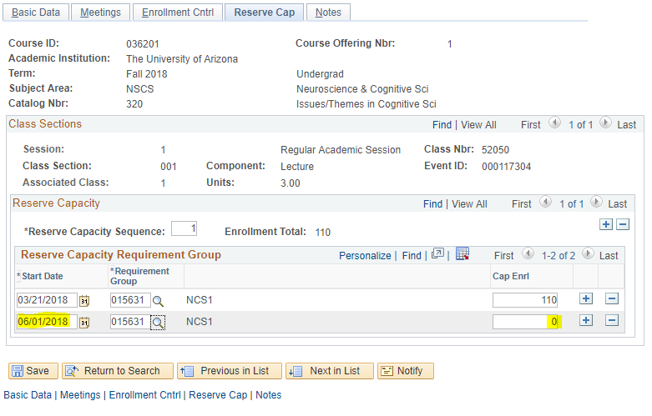
 | Save.

