Module: | Schedule of Classes Records
Business Process Name: | How to Manage Notes
Created By: | Marco Quintero
Creation Date: | 5/16/2018

Business Process Summary

This guide reviews how to add course Notes to a section.

Business Process Procedures:

Step A | Action— Adding Notes
Navigate to the course in Course Catalog. Administrative Staff>Navigator>Curriculum Management>Course Catalog>Course Catalog.

Go through Course Catalog Checklist
- Check that is Active
- Check Catalog Data
Min & Max Units
  - Repeat for Credit
  - Allow Multiple in Term
  - Cross listings
- Check Components
- Components (Required & Optional)
 | Navigate to the Schedule of Classes. Administrative Staff>Navigator>Curriculum Management>Schedule of Classes>Schedule New Course, or if sections already exist use Maintain Section of Classes.
Go to the Notes tab:

Schedule of Classes Checklist: “Notes”

Notes appear for students as they are registering for the class. Notes are meant to specify extra information that is needed for a student enrolling the course. Such as the MATH dept putting a Note on one of their courses indicating that students will need a TI-84 graphing calculator.

- Note Nbr: You may select that pre-defined note here and it will populate as a note. Notes frequenly

- Free Format Text: If you would like to create a unique note, you be define it here. A Note cannot contradict information that is on the Course Catalog or go against Course Catalog information.

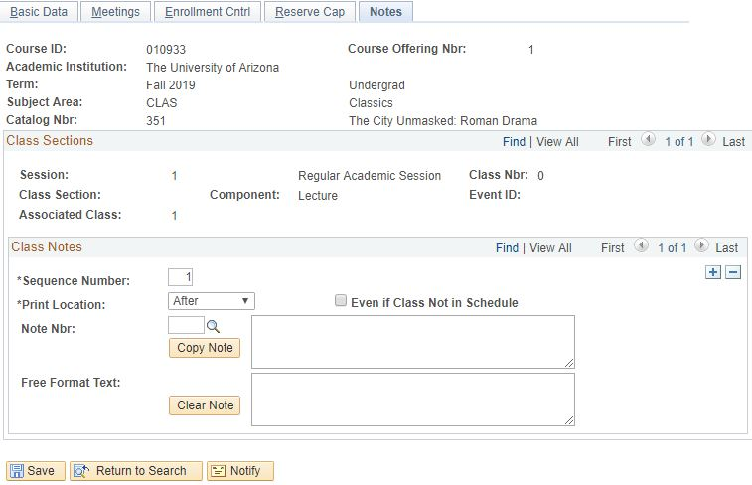
 | Save.

