Module: | Student Records
Business Process Name: | How to manage Enrollment tab
Created By: | Karina Valdez
Creation Date: | 5/17/2018

Business Process Summary

This guide reviews how to manage the Enrollment Tab in the Schedule of Classes. This BPG does not review how to add a whole course. For more help, go to the Office of the Registrar, Schedule of Classes Resources.

Business Process Procedures:

Step A | Action— How to manage Enrollment Tab
Navigate to the course in Course Catalog. UAccess Student> Administrative Staff>Navigator>Course Catalog>Course Catalog.

Go through Course Catalog Checklist
- Check that is Active
- Check Catalog Data
Min & Max Units
  - Repeat for Credit
  - Allow Multiple in Term
  - Cross listings
- Check Components
- Components (Required & Optional)
Navigate to the Schedule of Classes. UAccess Student> Administrative Staff>Navigator>Schedule of Classes>Schedule New Course, or if sections already exist use Maintain Section of Classes.

Go through Schedule of Classes checklist
Go to Enrollment tab:

Enrollment Cntrl
- Class Status: The status of the section must be “Active”.
- Add Consent: As requested by the department or instructor. This type of consent lets students know that they need approval from the department admin to be able to enroll in the section.
- Drop Consent: As requested by the department.
- Requested Room Capacity:
  - If you need a Centrally Scheduled Classroom (CSC)*,
    - RCS will help accommodate all sections that need a space for 12 or more students. Please place how big of a room is needed to accommodate this section. Please use historical enrollment as a guide on how large of a room you need for your section. If your section has been increasing enrollment over the last few years, please ask for a bigger room based on your growth history. The requested room capacity should not be larger than 70% of historical enrollment.
  - If you are using a Departmentally Scheduled Classroom (DSC),
    - Place a requested room capacity of 1 in this field.
  - If you are meeting Online,
    - Place a requested room capacity of 1 in this field.
- Enrollment Capacity: Enrollment of the section. The max amount of students the instructor or department admin want enroll in the section.
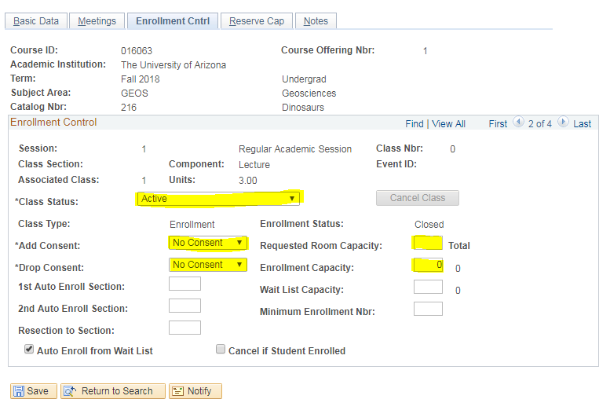
 | Save.
How to close enrollment:
Under Enrollment Ctrl Tab

First way to close enrollment:
- Set the enrollment cap at “0”. This way students might think that the class is full because it appears close but in but in reality the course doesn’t have any students as of now. (This can be changed at any moment).

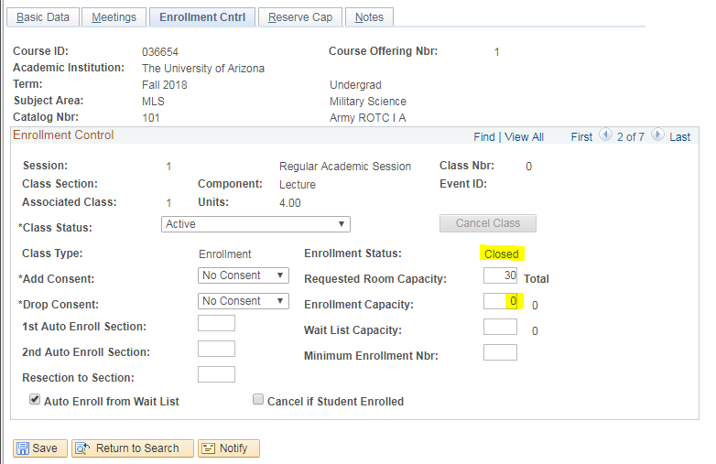
 | Save.
How to close enrollment:
Under Enrollment Ctrl Tab

Second way to close enrollment:
- Adding Dept Consent.
- Adding consent: This type of consent lets students know that they need approval from the department admin to be able to enroll in the course. (Only the department admin or instructor can ask for this consent).

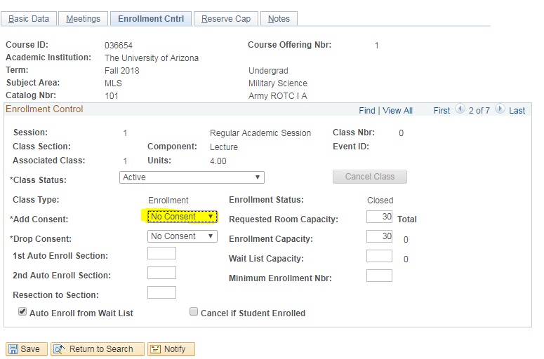
 | Save.

