Module: | Schedule of Classes Records
Business Process Name: | How to Add New Cross-Listed Section
Created By: | Marco Quintero/Suhina Deol
Creation Date: | 5/15/18

Business Process Summary

This guide reviews how to create a section to a course that is cross-listed. This BPG does not review in-person sections which are co-convened i.e. 400 undergraduate & 500 graduate combinations. A cross-listed course is when at the Course Catalog level a course is offered by a primary subject academic organization under multiple secondary subject prefixes i.e. MATH 567 (primary), STAT 567 (secondary, cross-listing with Math 567). A cross-listed course shares the same Meeting Tab in the Schedule of Classes across its primary and secondary subjects for one section. This means all students enrolled in the cross-listed course meet together, in the same room, at the same time/day, with the same instructor.

Business Process Procedures:

Step | Action— Adding a Cross-Listed Section
Course Catalog:

Navigate to the course in Course Catalog. UAccess Login. Administrative Staff>Navigator>Course Catalog>Course Catalog.

Course Catalog Checklist

- Check that it is Active
- Check Catalog Data
  - Min & Max Units
  - Repeat for Credit
  - Allow Multiple in Term
  - *Cross listings
    - The Offering tab will let you know if the course is cross-listed and what other subjects it is cross-listed with so you may schedule all the needed sections in the combination appropriately.
- Check Components
  - Components (Required & Optional)

(For more details, please review BPG-How to review the Course Catalog? and Course Catalog Checklist)
Schedule of Classes:

Navigate to the Schedule of Classes. Administrative Staff>Navigator>Schedule of Classes>Schedule New Course, or if sections already exist use Maintain Section of Classes.

*Remember!

- For Cross-Listed sections, repeat steps 3-6 of this BPG for each cross-listing (secondary courses).

- Make sure each section is set up identical to the other regarding the Basic Data, Enrollment Control, and Notes tabs.

- Wait! to set up the Meeting Tab until after you create the combination.

- Once each section in the cross-listing is created and set up correctly, create/edit the existing combined section in the combined sections table.

(For more details, please review BPG-How to review the Course Catalog? and Course Catalog Checklist)
Go to Basic Data tab:

Schedule of Classes Checklist: “Basic Data”
- Session: You may choose Regular Session, 7W1, 7W2, 5W1, 5W2, etc..
- Section & Associated Class:
  - IN PERSON sections should be 001-099 or 300-499
  - HYBRID sections should be 001-099 or 300-499
  - ICRSE sections should be 100-199
  - UAONLINE sections should be 200-299
  - Other:
- SPECIAL EXAM sections should be 751 and 752
- STUDY ABROAD sections should be 801-899
- Associated Class should match with section number without leading zeros or letters
    - i.e. Section = 001 & Associated Class=1
    - i.e. Section = 001A & Associated Class=1
    - i.e. Section = 101 & Associated Class=101
- Class Type: Should be enrollment for primary graded component. Non-enroll for all secondary components.
- Campus and Location:
  - IN PERSON
    - Campus = Main, etc…
    - Location=Tucson, etc…
  - HYBRID
    - Campus = Main, etc…
    - Location=Tucson, etc…
  - ICRSE
    - Campus = Main or UA South
    - Location=Tucson or South
  - UAONLINE
    - Campus = UA Online
    - Location=Online
- Instruction Mode:
  - IN PERSON
- P
  - HYBIRD
- HY
  - ICRSE
- FO
  - UAONLINE
- FO

- After creating each cross-listed section, copy down the “Class Nbr” circled in red below to make the combination in Step 9 to 11.

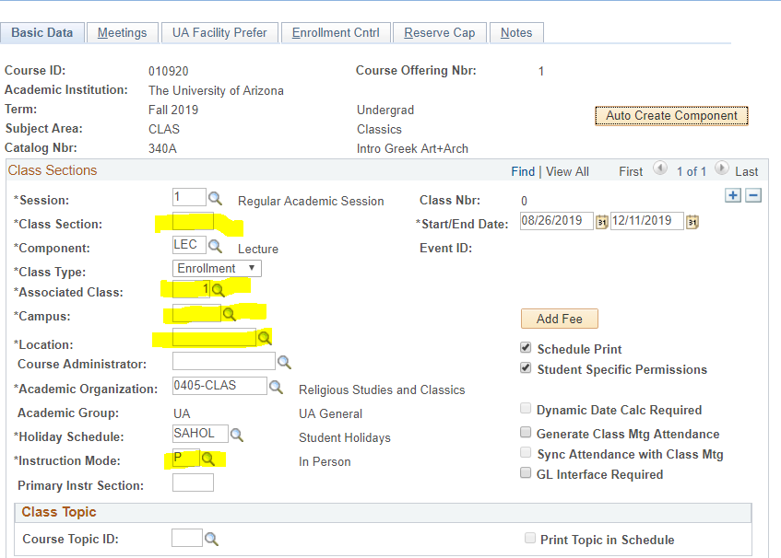

(For more details, please review BPG-How to manage Basic Data tab?)
Go to the Meetings tab:

Schedule of Classes Checklist: “Meetings”
- *Remember! Wait to set up the Meeting Tab until after you create the combination so move on to Step 5 of this BPG!

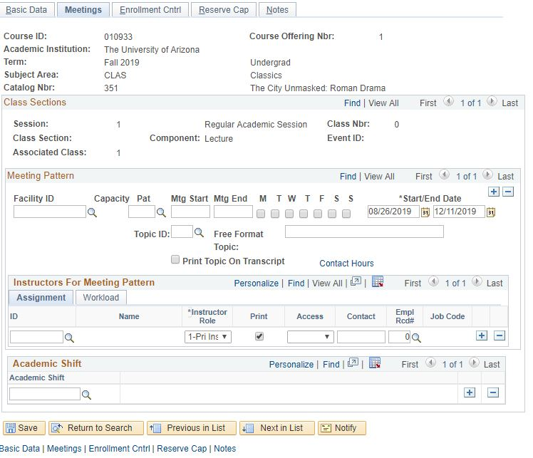

(For more details, please review BPG-How to manage Meetings tab?)
Go to Enrollment tab:

Schedule of Classes Checklist: “Enrollment Cntrl”
- Class Status: Must be Active
- Add Consent: As requested
- Drop Consent: As requested
- Requested Room Capacity:
  - Centrally Scheduled Classroom: greater or equal to 15
  - Dept. Scheduled Classroom: Change to 1
  - Online: Change to 1
- Enrollment Capacity: As requested

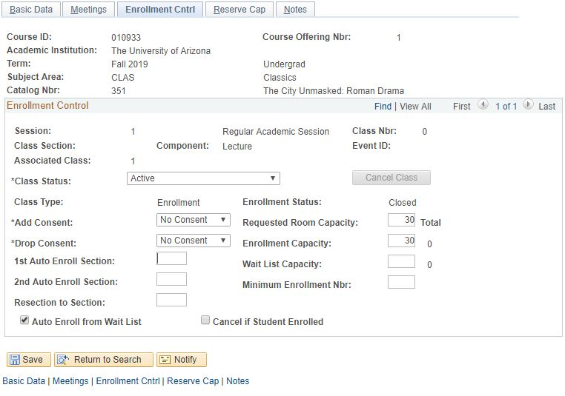

(For more details, please review BPG-How to manage Enrollment tab?)
Go to the Reserve Cap tab:

Schedule of Classes Checklist: “Reserve Cap”

- Reserve Capacity: As requested
- Reserve Capacity Sequence: As requested
- Enrollment Total: As requested
- Start Date: As requested
- Requirement Group: As requested
- Cap Enrl: As requested

(For more details, please review BPG-How to manage Reserve Cap tab?)
Go to Notes tab:

Schedule of Classes Checklist: “Notes”
- Note Nbr: As requested
- Free Format Text: As requested

(For more details, please review BPG-How to manage Notes tab?)
Remember!

- For Cross-Listed sections, repeat steps 3-7 of this BPG for each cross-listing (secondary courses)!

- Only after you set up each section in the cross-listing, you can move to step 9 of this BPG.

Go to Combined Sections to create/edit the cross-listing:

Navigate to Curriculum Management> Combined Sections> Combined Sections Table. Input the correct Term and Session, then hit search.

- Add a New Row
  - Press the plus sign to add a new combination to the Combined Sections Table (Please note: Never press the plus sign on the first Combined Sections ID that appears).

    - The Desciption of the course should be:
Subject Catablog# XLIST Section#

- The Short Descirption is:
SubjectCatablog#_Section#

Once Descitption’s are inputted, scroll to the bottom and save.

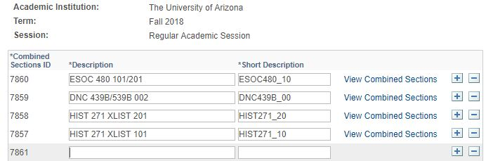
Every time a new combination has been created it is given a unique “Combined Sections ID” specific to Term and Session. Go to the correct Combined Sections ID and select “View Combined Sections” in order to input Class Nbr’s or cross-listed sections.

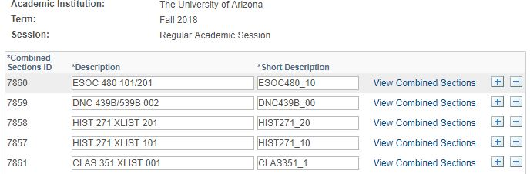

- Input the Class Nbr’s for the home dept and cross-listings associated to the combination.

- Be sure to insert a
  - Requested Room Capapcity
    - Centrally Scheduled Classroom: greater or equal to 15
    - Dept. Scheduled Classroom: Change to 1
    - Online: Change to 1
  - Combined Enrollment Capacity
    - As requested
  - Wait List Capacity
    - As requested

- After inputting a Class Nbr, press the plus sign to input a second (third, forth, etc.) Class Nbr from the list you copied down during Step 3.

- After placing all Class Nbr’s that need to be cross-listed in the combination, Save.

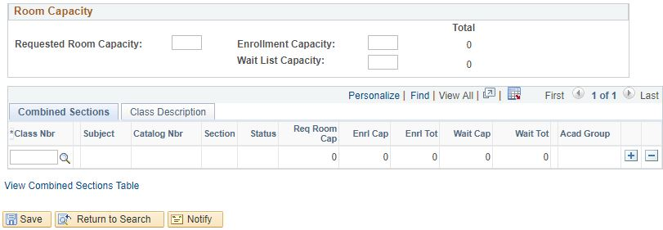

Navigate to Curriculum Management>Schedule of Classes>Schedule Class Meetings.

Go to the Meetings tab:

Schedule of Classes Checklist: “Meetings”
- Facility ID:
  - Centrally Scheduled Classroom: Leave blank
  - Dept. Scheduled Classroom: Place your classroom in here
  - Online: Place 999-ONLINE here
- Standard Meeting Pattern:
  - Centrally Scheduled Classroom: Place standard meeting pattern
  - Dept. Scheduled Classroom: Place any meeting pattern
  - Online: Place any meeting pattern or leave blank
- Instructor: You may enter employees ID, if you don’t have employees ID in hand you can search instructors first or last name by pressing the magnifying glass. Make sure to give at least one individual post access in “Instructors for Meeting Pattern”.
- Room Characteristics:
  - Centrally Scheduled Classroom: Select room characteristics you need by using the magnifying glass.
  - Dept. Scheduled Classroom: Leave blank
  - Online: Leave blank

(For more details, please go to BPG- How to Manage Tab in the Schedule of Classes).

*Only under the “Schedule Class Meetings” tab can meeting patterns and instructor information be changed for cross-listed sections. Changing the meeting pattern and Instructor information here will change it for all cross-listed sections in combination.

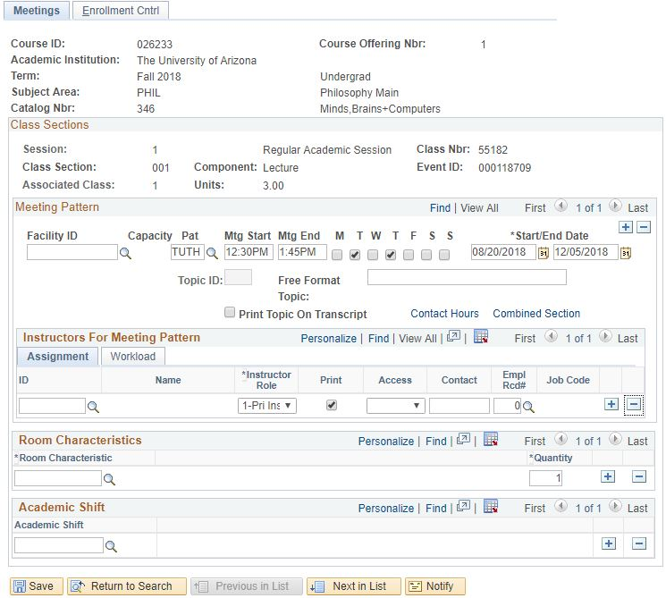

Save & Done!
TIPS & TRICKS

  - If a section is in a combination, if will have Combined Section appear until the meeting tab, see it circled in red below.

