Module: | Schedule of Classes Records
Business Process Name: | How to Add New Co-Convened Section
Created By: | Marco Quintero
Creation Date: | 5/16/18

Business Process Summary

This guide reviews how to create an in-person section to a course that is being co-convened with another. Typically this occurs between an undergraduate and graduate course (400/500 level). They are section numbers from 001-099 and 300-499.

Business Process Procedures:

Step A | Action— Adding a Co-Convened Section
Navigate to the Schedule of Classes. Administrative Staff>Navigator>Schedule of Classes>Schedule New Course, or if sections already exist use Maintain Section of Classes.
- Check that it is Active
- Check Catalog Data
  - Min & Max Units
  - Repeat for Credit
  - Allow Multiple in Term
  - Cross listings
- Check Components
  - Components (Required & Optional)

(For more details, please go to BPG- How to Read Course Catalog).
Navigate to the Schedule of Classes. Administrative Staff>Navigator>Curriculum Management>Schedule of Classes>Schedule New Course, or if sections already exist use Maintain Section of Classes.

In order to Co-Convene two courses (400/500), the two sections of each course will need to have an existing Class Nbr with the same Term and Session in order to place together in a combination.
Go to Basic Data Tab:

Schedule of Classes Checklist: “Basic Data”
- Session: You may choose Regular Session, 7W1, 7W2, 5W1, 5W2, etc..
- Section & Associated Class:
  - IN PERSON sections should be 001-099 or 300-499
  - HYBRID sections should be 001-099 or 300-499
  - ICRSE sections should be 100-199
  - UAONLINE sections should be 200-299
  - Other:
- SPECIAL EXAM sections should be 751 and 752
- STUDY ABROAD sections should be 801-899
- Associated Class should match with section number without leading zeros or letters
    - i.e. Section = 001 & Associated Class=1
    - i.e. Section = 001A & Associated Class=1
    - i.e. Section = 101 & Associated Class=101
- Class Type: Should be enrollment for primary graded component. Non-enroll for all secondary components.
- Campus and Location:
  - IN PERSON
    - Campus = Main, etc…
    - Location=Tucson, etc…
  - HYBRID
    - Campus = Main, etc…
    - Location=Tucson, etc…
  - ICRSE
    - Campus = Main or UA South
    - Location=Tucson or South
  - UAONLINE
    - Campus = UA Online
    - Location=Online
- Instruction Mode:
  - IN PERSON
- P
  - HYBIRD
- HY
  - ICRSE
- FO
  - UAONLINE
- FO

- After creating each cross-listed section copy down the “Class Nbr” circled in red below to make the combination process easier at the end.

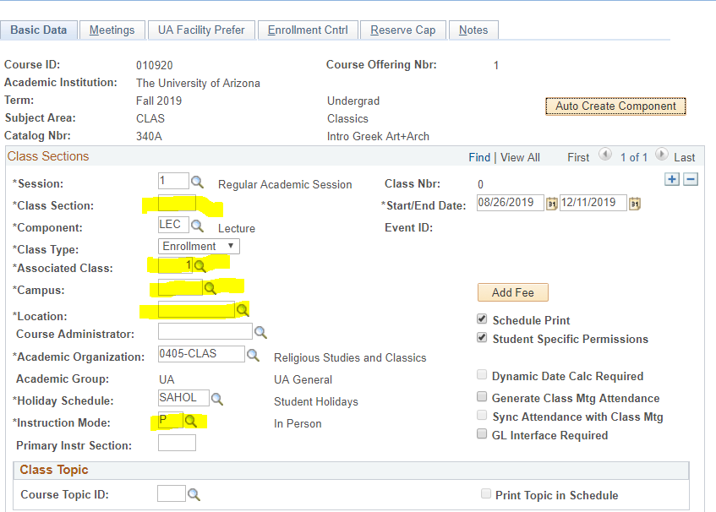

(For more details, please go to BPG- How to Manage Basic Data Tab in the Schedule of Classes).
Go to Meetings tab:

Schedule of Classes Checklist: “Meetings” (If Combined, do this last).
- Facility ID (Fill in Dept Controlled Rooms, Leave empty for Centrally Scheduled Classrooms)
- Standard Meeting Pattern
- Instructor

- *Remember! Wait to set up the Meeting Tab until after you create the combination so move on to Step 5 of this BPG!

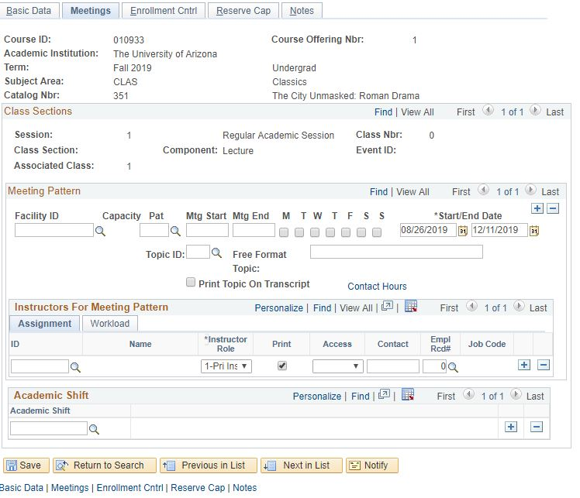

(For more details, please go to BPG- How to Manage Meetings Tab in the Schedule of Classes).
Go to Enrollment tab:

Schedule of Classes Checklist: “Enrollment Cntrl”
- Class Status
- Add Consent
- Drop Consent
- Requested Room Capacity
- Enrollment Capacity

*This is where departments can manipulate individual enrollment numbers between undergraduate and graduate courses that are Co-Convened. For example, if there should be 25 undergrad and only 5 graduate students in the course then set individual enrollment caps to 25 for the undergraduate and 5 for the graduate course, while setting the combined Enrollment Cap to 30 (step 9).

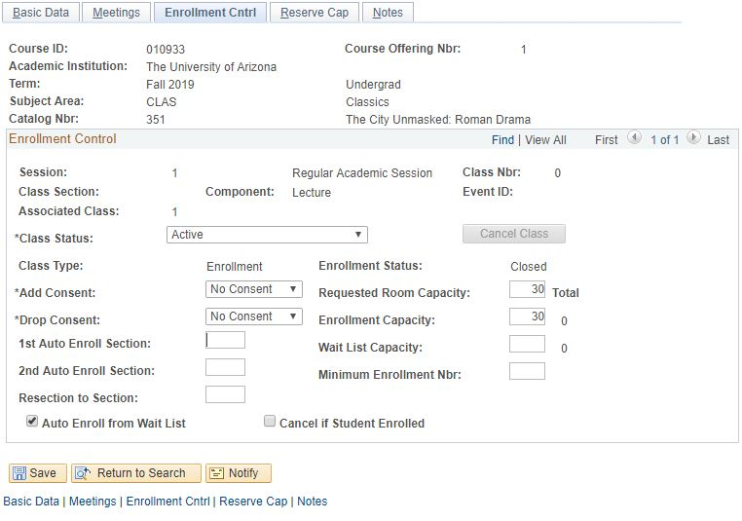

(For more details, please go to BPG- How to Manage Enrollment Tab in the Schedule of Classes).
Go to the Reserve Cap tab:

Schedule of Classes Checklist: “Reserve Cap”

- Reserve Capacity: As requested
- Reserve Capacity Sequence: As requested
- Enrollment Total: As requested
- Start Date: As requested
- Requirement Group: As requested
. Cap Enrl: As requested

(For more details, please go to BPG- How to Manage Reserve Cap Tab in the Schedule of Classes).

Go to Notes tab:

Schedule of Classes Checklist: “Notes”
- Note Nbr: As requested
- Free Format Text: As requested

(For more details, please go to BPG- How to Manage Notes Tab in the Schedule of Classes).

 | Save.
Combined Sections:

Navigate to Curriculum Management> Combined Sections> Combined Sections Table. Input the correct Term and Session, then hit search.

- Add a New Row
  - Press the plus sign to add a new combination to the Combined Sections Table (Please note: Never press the plus sign on the first Combined Sections ID that appears).

    - The Desciption of the course should be:
Subject Catablog# XLIST Section#

- The Short Descirption is:
SubjectCatablog#_Section#

Once Descitption’s are inputted, scroll to the bottom and save.

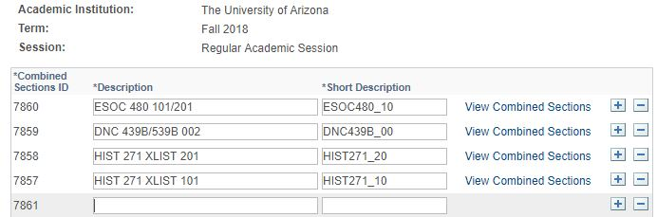
Every time a new combination has been created it is given a unique Combined Sections ID specific to Term and Session. After saving the Descriptions, go to the correct Combined Sections ID and select “View Combined Sections” to input Class Nbr’s.

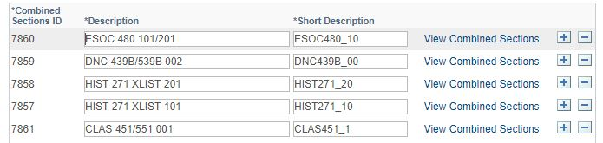

Input the Class Nbr’s for the home dept’s and cross-listings associated to the combination.

Be sure to insert a
Requested Room Capapcity
    - Centrally Scheduled Classroom: greater or equal to 15
    - Dept. Scheduled Classroom: Change to 1
    - Online: Change to 1
Combined Enrollment Capacity
    - As requested
Wait List Capacity
    - As requested

After inputting a Class Nbr, press the plus sign to input a second (third, forth, etc.) Class Nbr from the list you copied down during Step 3.

After placing all Class Nbr’s that need to be cross-listed in the combination, Save.

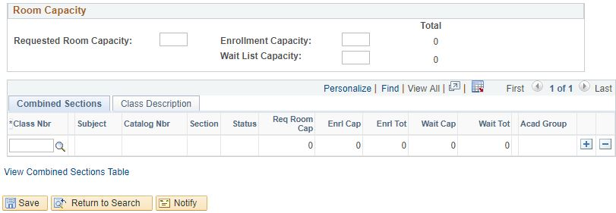
Navigate to Curriculum Management>Schedule of Classes>Schedule Class Meetings.
- Filter by Term, Subject Area, and Catalog Nbr.

Go to the Meetings tab:

Schedule of Classes Checklist: “Meetings”
- Facility ID:
  - Centrally Scheduled Classroom: Leave blank
  - Dept. Scheduled Classroom: Place your classroom in here
  - Online: Place 999-ONLINE here
- Standard Meeting Pattern:
  - Centrally Scheduled Classroom: Place standard meeting pattern
  - Dept. Scheduled Classroom: Place any meeting pattern
  - Online: Place any meeting pattern or leave blank
- Instructor: You may enter employees ID, if you don’t have employees ID in hand you can search instructors first or last name by pressing the magnifying glass. Make sure to give at least one individual post access in “Instructors for Meeting Pattern”.
- Room Characteristics:
  - Centrally Scheduled Classroom: Select room characteristics you need by using the magnifying glass.
  - Dept. Scheduled Classroom: Leave blank
  - Online: Leave blank

(For more details, please go to BPG- How to Manage Meetings Tab in the Schedule of Classes).

*Only under the “Schedule Class Meetings” tab can meeting patterns and instructor information be changed for Co –Convened sections. Changing the meeting pattern and Instructor information here will change it for all cross-listed sections in combination.

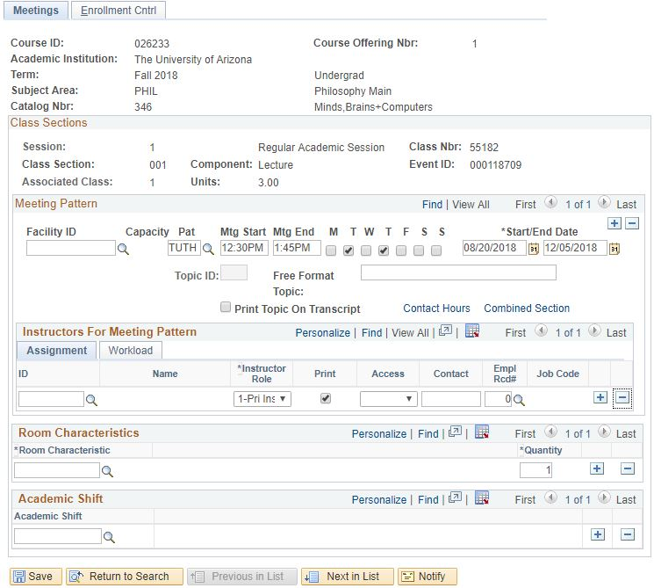
 | Save & Done!
TIPS & TRICKS

  - If a section is in a combination, if will have Combined Section appear until the meeting tab, see it circled in red below.

