Module: | Student Records
Business Process Name: | Adding multiple components
Created By: | Karina Valdez/Suhina Deol
Creation Date: | 5/22/2018

Business Process Summary

This guide reviews how to add multiple components in a course in the schedule of classes. For more information, go to Schedule of Classes Resources.

Business Process Procedures:

Step A | Action— Adding Multiple Components Section
Course Catalog:

Navigate to the course in Course Catalog. UAccess Login. Administrative Staff>Navigator>Course Catalog>Course Catalog.

Course Catalog Checklist
- Check that is Active
- Check Catalog Data
Min & Max Units
  - Repeat for Credit
  - Allow Multiple in Term
  - Cross listings
- Check Components
- Components (Required & Optional)
  - If more than 1, you have multiple components to manage for this course when creating sections in the Schedule of Classes.

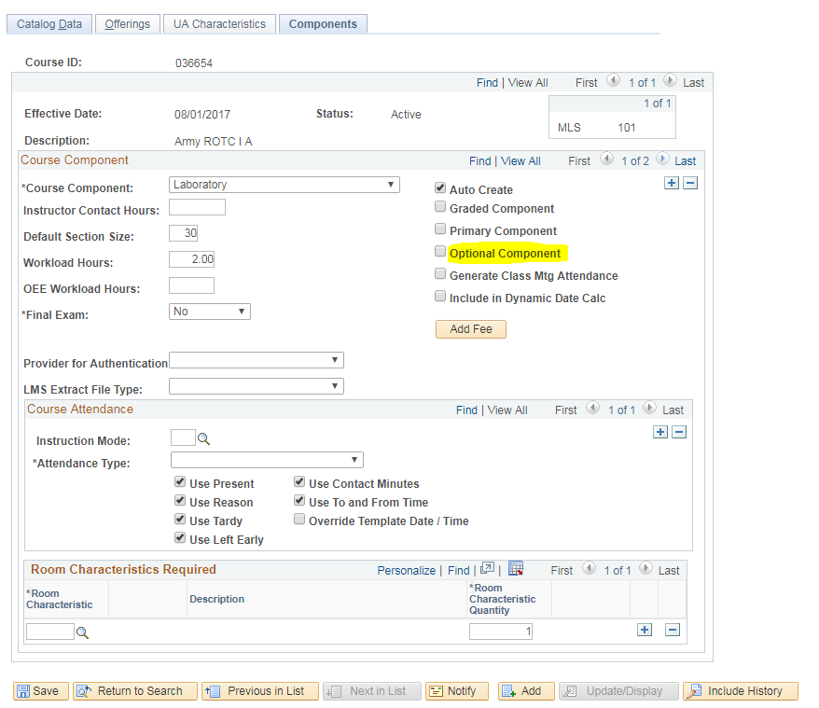

Schedule of Classes:

Navigate to the Schedule of Classes. Administrative Staff>Navigator>Schedule of Classes>Schedule New Course, or if sections already exist use Maintain Section of Classes.

Go to Basic Data tab:
Schedule of Classes Checklist: “Basic Data”
- Session: You may choose Regular Session, 7W1, 7W2, 5W1, 5W2, etc..
- Section & Associated Class:
  - IN PERSON sections should be 001-099 or 300-499
  - HYBRID sections should be 001-099 or 300-499
  - ICRSE sections should be 100-199
  - UAONLINE sections should be 200-299
  - Other:
- SPECIAL EXAM sections should be 751 and 752
- STUDY ABROAD sections should be 801-899
- Associated Class should match with section number without leading zeros or letters
    - i.e. Section = 001 & Associated Class=1
    - i.e. Section = 001A & Associated Class=1
    - i.e. Section = 101 & Associated Class=101
- Class Type: Should be ENROLL for primary graded component.
Campus and Location:
  - IN PERSON
    - Campus = Main, etc…
    - Location=Tucson, etc…
  - HYBRID
    - Campus = Main, etc…
    - Location=Tucson, etc…
  - ICRSE
    - Campus = Main or UA South
    - Location=Tucson or South
  - UAONLINE
    - Campus = UA Online
    - Location=Online
- Instruction Mode:
  - IN PERSON
- P
  - HYBIRD
- HY
  - ICRSE
- FO
  - UAONLINE
- FO

Go to the Meetings tab:

Schedule of Classes Checklist: “Meetings”
- Facility ID:
  - Centrally Scheduled Classroom: Leave blank
  - Dept. Scheduled Classroom: Place your classroom in here
  - Online: Place 999-ONLINE here
- Standard Meeting Pattern:
  - Centrally Scheduled Classroom: Place standard meeting pattern
  - Dept. Scheduled Classroom: Place any meeting pattern
  - Online: Place any meeting pattern or leave blank
- Instructor: You may enter employees ID, if you don’t have employees ID in hand you can search instructors first or last name by pressing the magnifying glass. Make sure to give at least one individual post access in “Instructors for Meeting Pattern”.
- Room Characteristics:
  - Centrally Scheduled Classroom: Select room characteristics you need by using the magnifying glass.
  - Dept. Scheduled Classroom: Leave blank
  - Online: Leave blank
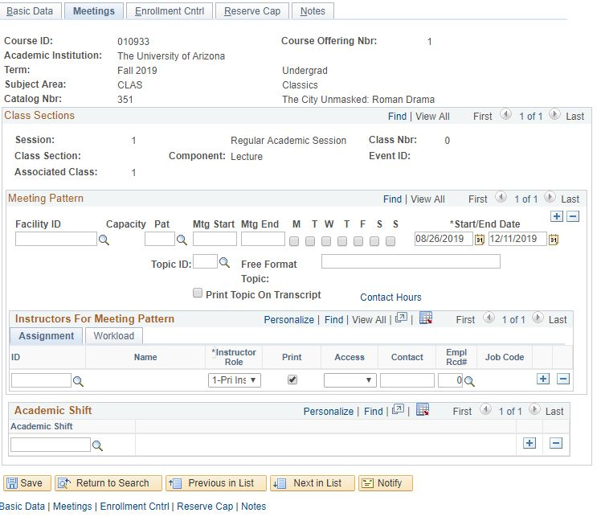

(For more details, please review BPG-How to manage Meetings tab?)
Go to Enrollment tab:

Schedule of Classes Checklist: “Enrollment Cntrl”
- Class Status: Must be Active
- Add Consent: As requested
- Drop Consent: As requested
- Requested Room Capacity:
  - Centrally Scheduled Classroom: greater or equal to 15
  - Dept. Scheduled Classroom: Change to 1
  - Online: Change to 1
- Enrollment Capacity: As requested

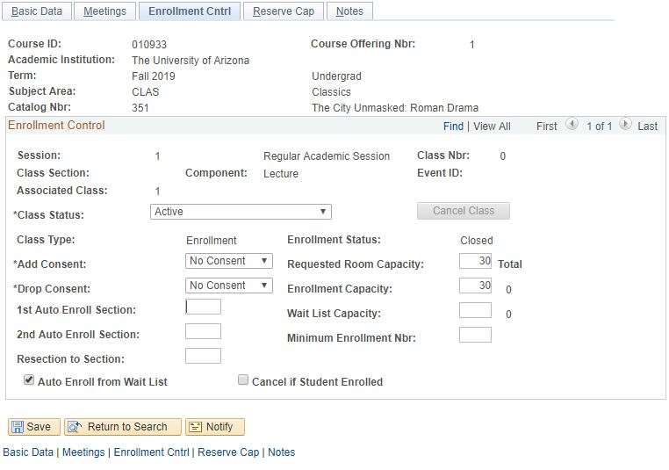

(For more details, please review BPG-How to manage Enrollment tab?)
Go to the Reserve Cap tab:

Schedule of Classes Checklist: “Reserve Cap”

- Reserve Capacity: As requested
- Reserve Capacity Sequence: As requested
- Enrollment Total: As requested
- Start Date: As requested
- Requirement Group: As requested
- Cap Enrl: As requested

(For more details, please review BPG-How to manage Reserve Cap tab?)
Go to Notes tab:

Schedule of Classes Checklist: “Notes”
- Note Nbr: As requested
- Free Format Text: As requested

(For more details, please review BPG-How to manage Notes tab?)
Now you need to create the non-enrollment component sections!

Go to Basic Data tab:
Schedule of Classes Checklist: “Basic Data”
- Session: You may choose Regular Session, 7W1, 7W2, 5W1, 5W2, etc..
- Section & Associated Class:
  - IN PERSON sections should be 001-099 or 300-499
  - HYBRID sections should be 001-099 or 300-499
  - ICRSE sections should be 100-199
  - UAONLINE sections should be 200-299
  - Other:
- SPECIAL EXAM sections should be 751 and 752
- STUDY ABROAD sections should be 801-899
- Associated Class should match with section number without leading zeros or letters
    - i.e. Section = 001 & Associated Class=1
    - i.e. Section = 001A & Associated Class=1
    - i.e. Section = 101 & Associated Class=101
- Class Type: Should be NON-ENROLL for primary graded component.
Campus and Location:
  - IN PERSON
    - Campus = Main, etc…
    - Location=Tucson, etc…
  - HYBRID
    - Campus = Main, etc…
    - Location=Tucson, etc…
  - ICRSE
    - Campus = Main or UA South
    - Location=Tucson or South
  - UAONLINE
    - Campus = UA Online
    - Location=Online
- Instruction Mode:
  - IN PERSON
- P
  - HYBIRD
- HY
  - ICRSE
- FO
  - UAONLINE
- FO

Repeat Steps 4 thru 7 for the NON-ENROLL component sections.
Repeat Steps 8 thru 9 for each additional NON-ENROLL component you have listed in the Course Catalog.
Save & Done!

