Module: | Student Records
Business Process Name: | How to Add/Maintain an UAOnline Section
Created By: | Karina Valdez/Suhina Deol
Creation Date: | 5/15/2018

Business Process Summary

This guide review how to add/maintain UAOnline sections which are fully online and for online campus students. They are section numbers 201-299.

Business Process Procedures:

Step A | Action— Adding an ONLINE Section
Course Catalog:

Navigate to the course in Course Catalog. UAccess Login. Administrative Staff>Navigator>Course Catalog>Course Catalog.

Course Catalog Checklist

- Check that it is Active
- Check Catalog Data
  - Min & Max Units
  - Repeat for Credit
  - Allow Multiple in Term
  - Cross listings
- Check Components
  - Components (Required & Optional)

(For more details, please review BPG-How to review the Course Catalog? and Course Catalog Checklist)
Schedule of Classes:

Navigate to the Schedule of Classes. Administrative Staff>Navigator>Schedule of Classes>Schedule New Course, or if sections already exist use Maintain Section of Classes

Go through Schedule of Classes checklist
Go to Basic Data tab:
Schedule of Classes Checklist: “Basic Data”
- Session: You may choose Regular Session, 7W1, 7W2, 5W1, 5W2, etc..
- Section & Associated Class:
  - UAONLINE sections should be 200-299
  - Other:
- SPECIAL EXAM sections should be 751 and 752
- STUDY ABROAD sections should be 801-899
- Associated Class should match with section number without leading zeros or letters
    - i.e. Section = 001 & Associated Class=1
    - i.e. Section = 001A & Associated Class=1
    - i.e. Section = 101 & Associated Class=101
- Class Type: Should be enrollment for primary graded component. Non-enroll for all secondary components.
- Campus and Location:
  - UAONLINE
    - Campus = UA Online
    - Location=Online
- Instruction Mode:
  - UAONLINE
- FO

(For more details, please go to BPG- How to manage Basic Data Tab in the Schedule of Classes).
Go to the Meetings tab:

Schedule of Classes Checklist: “Meetings”
- Facility ID:
  - Online: Place 999-ONLINE here
- Standard Meeting Pattern:
  - Online: Place any meeting pattern or leave blank
- Instructor: You may enter employees ID, if you don’t have employees ID in hand you can search instructors first or last name by pressing the magnifying glass. Make sure to give at least one individual post access in “Instructors for Meeting Pattern”.
- Room Characteristics:
  - Online: Leave blank

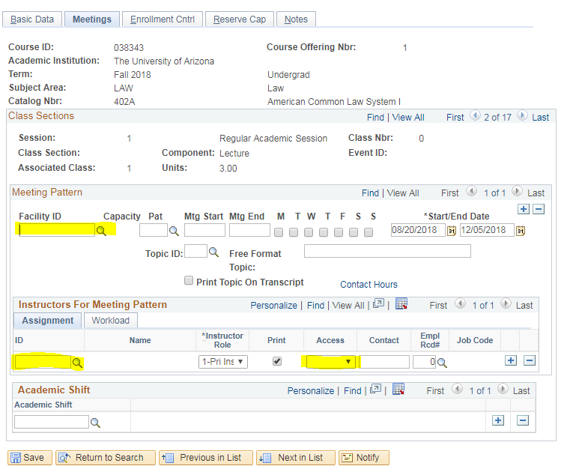

(For more details, please go to BPG- How to manage Meetings Tab in the Schedule of Classes).
Go to Enrollment tab:

Schedule of Classes Checklist: “Enrollment Cntrl”
- Class Status: Must be Active
- Add Consent: As requested
- Drop Consent: As requested
- Requested Room Capacity: Change to 1.
- Enrollment Capacity: As requested

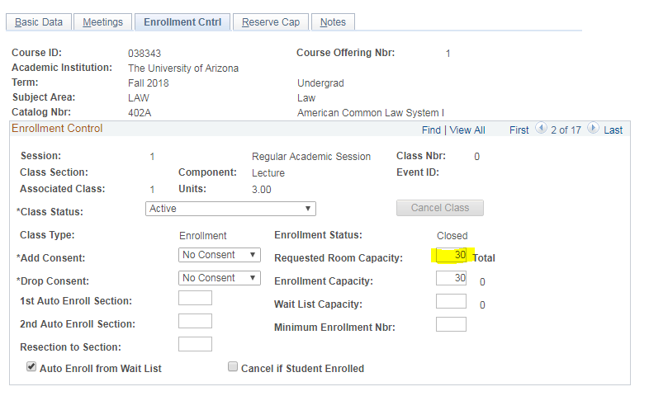

(For more details, please go to BPG- How to manage Enrollment Tab in the Schedule of Classes).
Go to the Reserve Cap tab:

Schedule of Classes Checklist: “Reserve Cap”

- Reserve Capacity: As requested
- Reserve Capacity Sequence: As requested
- Enrollment Total: As requested
- Start Date: As requested
- Requirement Group: As requested
- Cap Enrl: As requested

(For more details, please review BPG-How to manage Reserve Cap tab?)
Go to Notes tab:

Schedule of Classes Checklist: “Notes”
- Note Nbr: As requested
- Free Format Text: As requested

(For more details, please review BPG-How to manage Notes tab?)
Go to the Class Requisites tab.

Navigate to Curriculum Management> Schedule of Classes> Adjust Class Associations

Under “Class Association Requisites”, add Requirement Group “016803”. This requirement group is ONLY for UA-Online Campus Students.

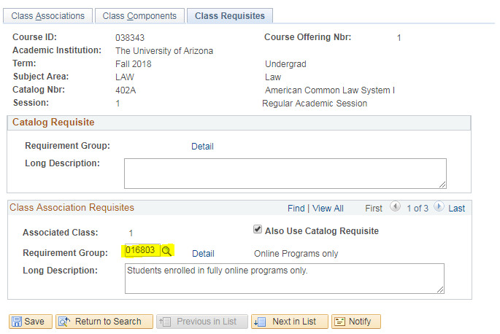
Check – Do additional steps here if there are multiple required components.
After Open Scheduling, be sure there are department submitted add forms for secondary components to process with the primary component form.

Check – Do additional steps here if there are cross-listings.
After Open Scheduling, be sure the department submitted the form for the primary offering.
13. | Check – Do additional steps here if there are co-convened sections.  After Open Scheduling, be sure there are department submitted add/cancel/change forms for other co-convened sections to process.
14. | Check- Do additional steps here if this has special class attributes i.e. Honors, Engagement, etc.
15. | Check- Do additional steps here if there are special class requirement groups i.e. Honors, UAOnline Students Only, etc.
16. | Save & Done!

