Module: | Student Records
Business Process Name: | How to Add/Maintain an Honors Section
Created By: | Karina Valdez/Suhina Deol
Creation Date: | 5/16/2018

Business Process Summary
This guide reviews how to add/maintain an Honors section. For more information, go to Schedule of Classes Resources.

Business Process Procedures:

Step A | Action— How to Add/Maintain an Honors Section
Course Catalog:

Navigate to the course in Course Catalog. UAccess Login. Administrative Staff>Navigator>Course Catalog>Course Catalog.

Course Catalog Checklist

- Check that it is Active
- Check Catalog Data
  - Min & Max Units
  - Repeat for Credit
  - Allow Multiple in Term
  - Cross listings
- Check Components
  - Components (Required & Optional)

(For more details, please review BPG-How to review the Course Catalog? and Course Catalog Checklist)
Schedule of Classes:

Navigate to the Schedule of Classes. Administrative Staff>Navigator>Schedule of Classes>Schedule New Course, or if sections already exist use Maintain Section of Classes

Go through Schedule of Classes checklist
Go to Basic Data tab:
Schedule of Classes Checklist: “Basic Data”
- Session: You may choose Regular Session, 7W1, 7W2, 5W1, 5W2, etc..
- Section & Associated Class:
  - IN PERSON sections should be 001-099 or 300-499
  - HYBRID sections should be 001-099 or 300-499
  - ICRSE sections should be 100-199
  - UAONLINE sections should be 200-299
  - Other:
- SPECIAL EXAM sections should be 751 and 752
- STUDY ABROAD sections should be 801-899
- Associated Class should match with section number without leading zeros or letters
    - i.e. Section = 001 & Associated Class=1
    - i.e. Section = 001A & Associated Class=1
    - i.e. Section = 101 & Associated Class=101
- Class Type: Should be enrollment for primary graded component. Non-enroll for all secondary components.
- Campus and Location:
  - IN PERSON
    - Campus = Main, etc…
    - Location=Tucson, etc…
  - HYBRID
    - Campus = Main, etc…
    - Location=Tucson, etc…
  - ICRSE
    - Campus = Main or UA South
    - Location=Tucson or South
  - UAONLINE
    - Campus = UA Online
    - Location=Online
- Instruction Mode:
  - IN PERSON
- P
  - HYBIRD
- HY
  - ICRSE
- FO
  - UAONLINE
- FO
- Class Attributes:
- *Honors: Under “Class Attributes” on the same tab, using the magnifying glass click “HNRS” and “HCRS” (Honors Course).

Go to the Meetings tab:

Schedule of Classes Checklist: “Meetings”
- Facility ID:
  - Centrally Scheduled Classroom: Leave blank
  - Dept. Scheduled Classroom: Place your classroom in here
  - Online: Place 999-ONLINE here
- Standard Meeting Pattern:
  - Centrally Scheduled Classroom: Place standard meeting pattern
  - Dept. Scheduled Classroom: Place any meeting pattern
  - Online: Place any meeting pattern or leave blank
- Instructor: You may enter employees ID, if you don’t have employees ID in hand you can search instructors first or last name by pressing the magnifying glass. Make sure to give at least one individual post access in “Instructors for Meeting Pattern”.
- Room Characteristics:
  - Centrally Scheduled Classroom: Select room characteristics you need by using the magnifying glass.
  - Dept. Scheduled Classroom: Leave blank
  - Online: Leave blank

(For more details, please go to BPG- How to Manage Tab in the Schedule of Classes).

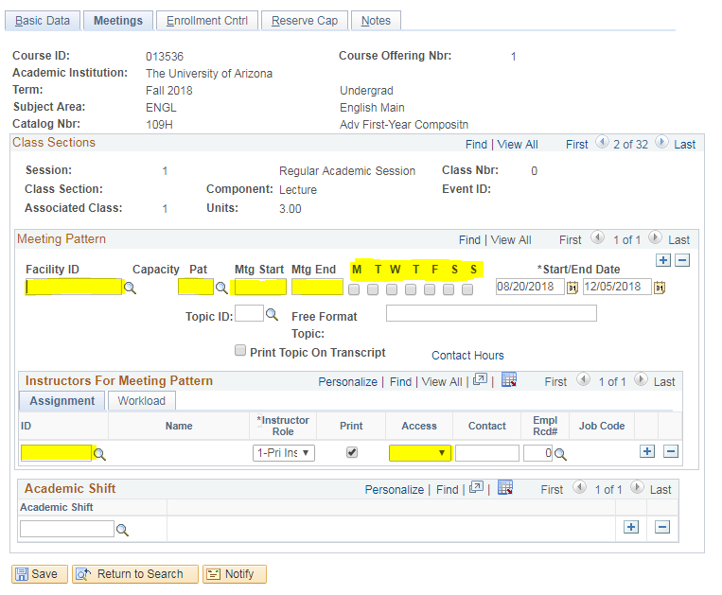
Go to Enrollment tab:

Schedule of Classes Checklist: “Enrollment Cntrl”
- Class Status: Must be Active
- Add Consent: As requested
- Drop Consent: As requested
- Requested Room Capacity:
  - Centrally Scheduled Classroom: greater or equal to 15
  - Dept. Scheduled Classroom: Change to 1
  - Online: Change to 1
- Enrollment Capacity: As requested

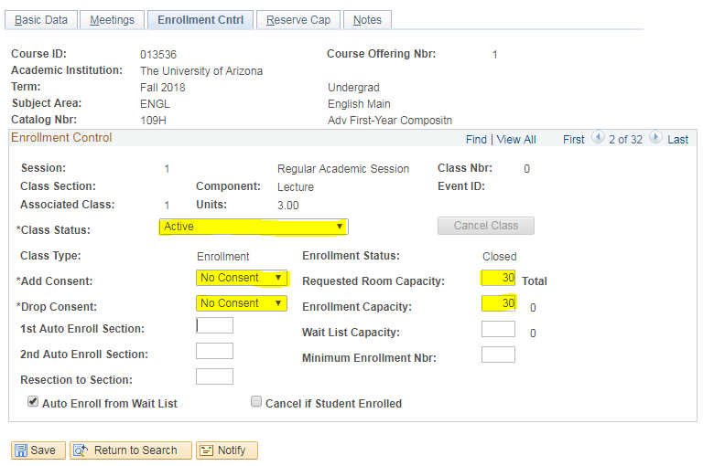
(For more details, please review BPG-How to manage Enrollment tab?)
Go to the Reserve Cap tab:

Schedule of Classes Checklist: “Reserve Cap”

- Reserve Capacity: As requested
- Reserve Capacity Sequence: As requested
- Enrollment Total: As requested
- Start Date: As requested
- Requirement Group: As requested
- Cap Enrl: As requested

(For more details, please review BPG-How to manage Reserve Cap tab?)
Go to Notes tab:

Schedule of Classes Checklist: “Notes”
- Note Nbr: As requested
- Free Format Text: As requested

(For more details, please review BPG-How to manage Notes tab?)
For Honors Sections:
- Check 1 - Class Attributes: Completed in Step 2.

Go to Curriculum Management>Schedule of Classes>Adjust Class Association.

- Check 2: Requirement Designation: In the “Class Components tab”, under Class Association Components make sure to click the magnifying glass next to “Requirement Designation” and search “HONR” (Contact Room and Course Scheduling for help).

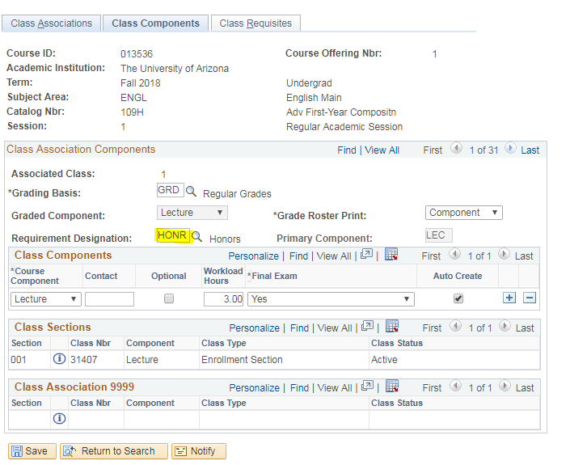

Check 3: Requirement Group: In the next tab, “Class Requisites” under Class Association Requisites make sure to type requirement group “015056” or search on the magnifying glass for “Honors Active”. After doing so, underneath where it says long description, it should auto populate and it should say “Student must be active in the Honors College”.

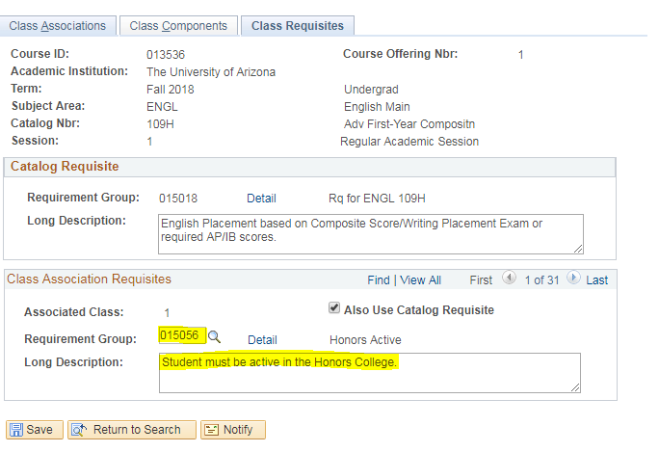
Check – Do additional steps here if there are multiple required components.
After Open Scheduling, be sure there are department submitted add forms for secondary components to process with the primary component form.
Check – Do additional steps here if there are cross-listings.
After Open Scheduling, be sure the department submitted the form for the primary offering.
Check – Do additional steps here if there are co-convened sections.
After Open Scheduling, be sure there are department submitted add/cancel/change forms for other co-convened sections to process.
 | Check- Do additional steps here if this has special class attributes i.e. Honors, Engagement, etc.
 | Check- Do additional steps here if there are special class requirement groups i.e. Honors, UAOnline Students Only, etc.
 | Save & Done!

