Module: | Schedule of Classes Records
Business Process Name: | How to Add/Maintain Hybrid, Non-Combined, & Non-Honors Section
Created By: | Suhina Deol
Creation Date: | 5/15/18

Business Process Summary

This guide reviews how to create/maintain a hybrid section to a course or a hybrid, non-combined, & regular/non-honors section. The main difference between a hybrid is that it is BOTH a 1) Physical location Facility ID Meeting and a 2) Online location Facility ID Meeting. For more information, go to Schedule of Classes Resources.

Business Process Procedures:

Step | Action— Adding a Cross-Listed Section
Course Catalog:

Navigate to the course in Course Catalog. UAccess Login. Administrative Staff>Navigator>Course Catalog>Course Catalog.

Course Catalog Checklist

- Check that it is Active
- Check Catalog Data
  - Min & Max Units
  - Repeat for Credit
  - Allow Multiple in Term
  - Cross listings
- Check Components
  - Components (Required & Optional)

(For more details, please review BPG-How to review the Course Catalog? and Course Catalog Checklist)
Schedule of Classes:

Navigate to the Schedule of Classes. Administrative Staff>Navigator>Schedule of Classes>Schedule New Course, or if sections already exist use Maintain Section of Classes.

Go to Basic Data tab:

Schedule of Classes Checklist: “Basic Data”
- Session: You may choose Regular Session, 7W1, 7W2, 5W1, 5W2, etc..
- Section & Associated Class:
  - HYBRID sections should be 001-099 or 300-499
  - Other:
- SPECIAL EXAM sections should be 751 and 752
- STUDY ABROAD sections should be 801-899
- Associated Class should match with section number without leading zeros or letters
    - i.e. Section = 001 & Associated Class=1
    - i.e. Section = 001A & Associated Class=1
    - i.e. Section = 101 & Associated Class=101
- Class Type: Should be enrollment for primary graded component. Non-enroll for all secondary components.
- Campus and Location:
  - HYBRID
    - Campus = Main, etc…
    - Location=Tucson, etc…
- Instruction Mode:
  - HYBRID
- HY

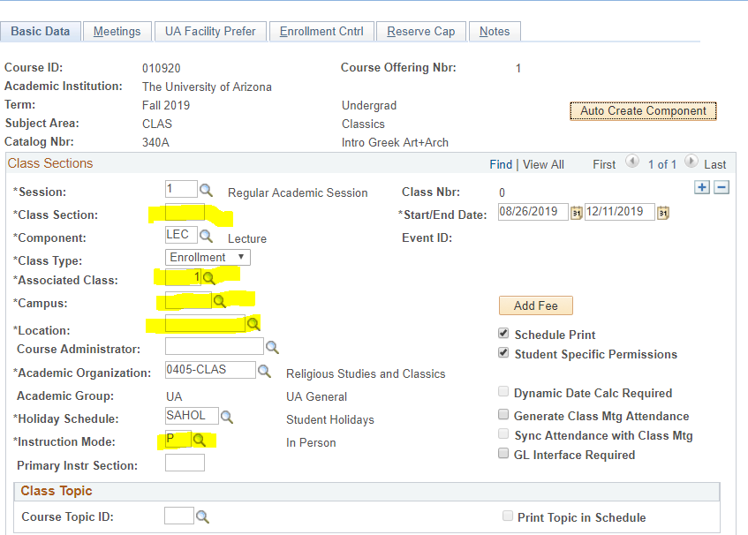

(For more details, please review BPG-How to manage Basic Data tab?)
Go to the Meetings tab:

Schedule of Classes Checklist: “Meetings”
- Facility ID:
  - Add one physical location:
    - Centrally Scheduled Classroom: Leave blank
    - Or Dept. Scheduled Classroom: Place your classroom in here
  - Add one online location:
    - Online: Place 999-ONLINE here
- Standard Meeting Pattern:
  - Physical: Place any meeting pattern which falls into a standard meeting pattern
  - Online: Place any meeting pattern or leave blank
- Instructor: You may enter employees ID, if you don’t have employees ID in hand you can search instructors first or last name by pressing the magnifying glass. Make sure to give at least one individual post access in “Instructors for Meeting Pattern”.
- Room Characteristics:
  - Centrally Scheduled Classroom: Select room characteristics you need by using the magnifying glass.
  - Dept. Scheduled Classroom: Leave blank
  - Online: Leave blank
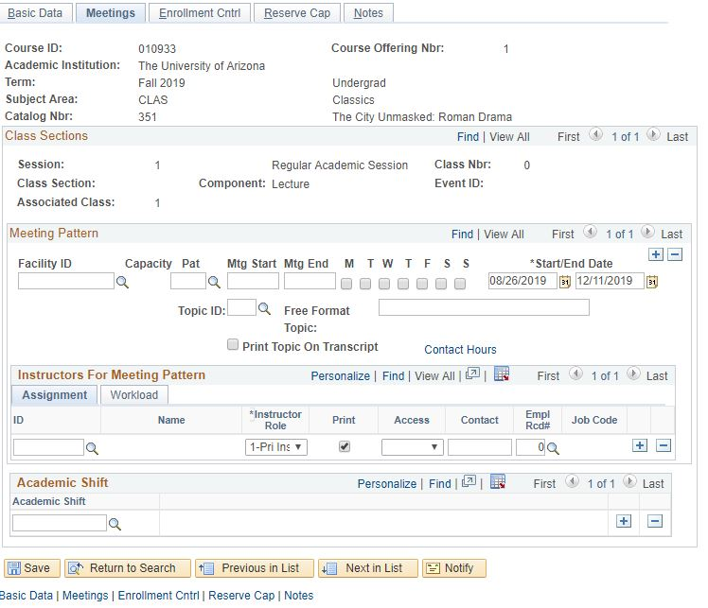

(For more details, please review BPG-How to manage Meetings tab?)
Go to Enrollment tab:

Schedule of Classes Checklist: “Enrollment Cntrl”
- Class Status: Must be Active
- Add Consent: As requested
- Drop Consent: As requested
- Requested Room Capacity:
  - Centrally Scheduled Classroom: greater or equal to 15
  - Dept. Scheduled Classroom: Change to 1
  - Online: Change to 1
- Enrollment Capacity: As requested

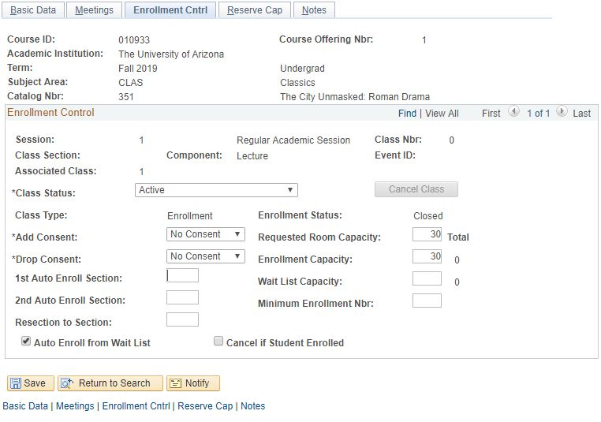

(For more details, please review BPG-How to manage Enrollment tab?)
Go to the Reserve Cap tab:

Schedule of Classes Checklist: “Reserve Cap”

- Reserve Capacity: As requested
- Reserve Capacity Sequence: As requested
- Enrollment Total: As requested
- Start Date: As requested
- Requirement Group: As requested
- Cap Enrl: As requested

(For more details, please review BPG-How to manage Reserve Cap tab?)
Go to Notes tab:

Schedule of Classes Checklist: “Notes”
- Note Nbr: As requested
- Free Format Text: As requested

(For more details, please review BPG-How to manage Notes tab?)
 | Save & Done!

